##### 

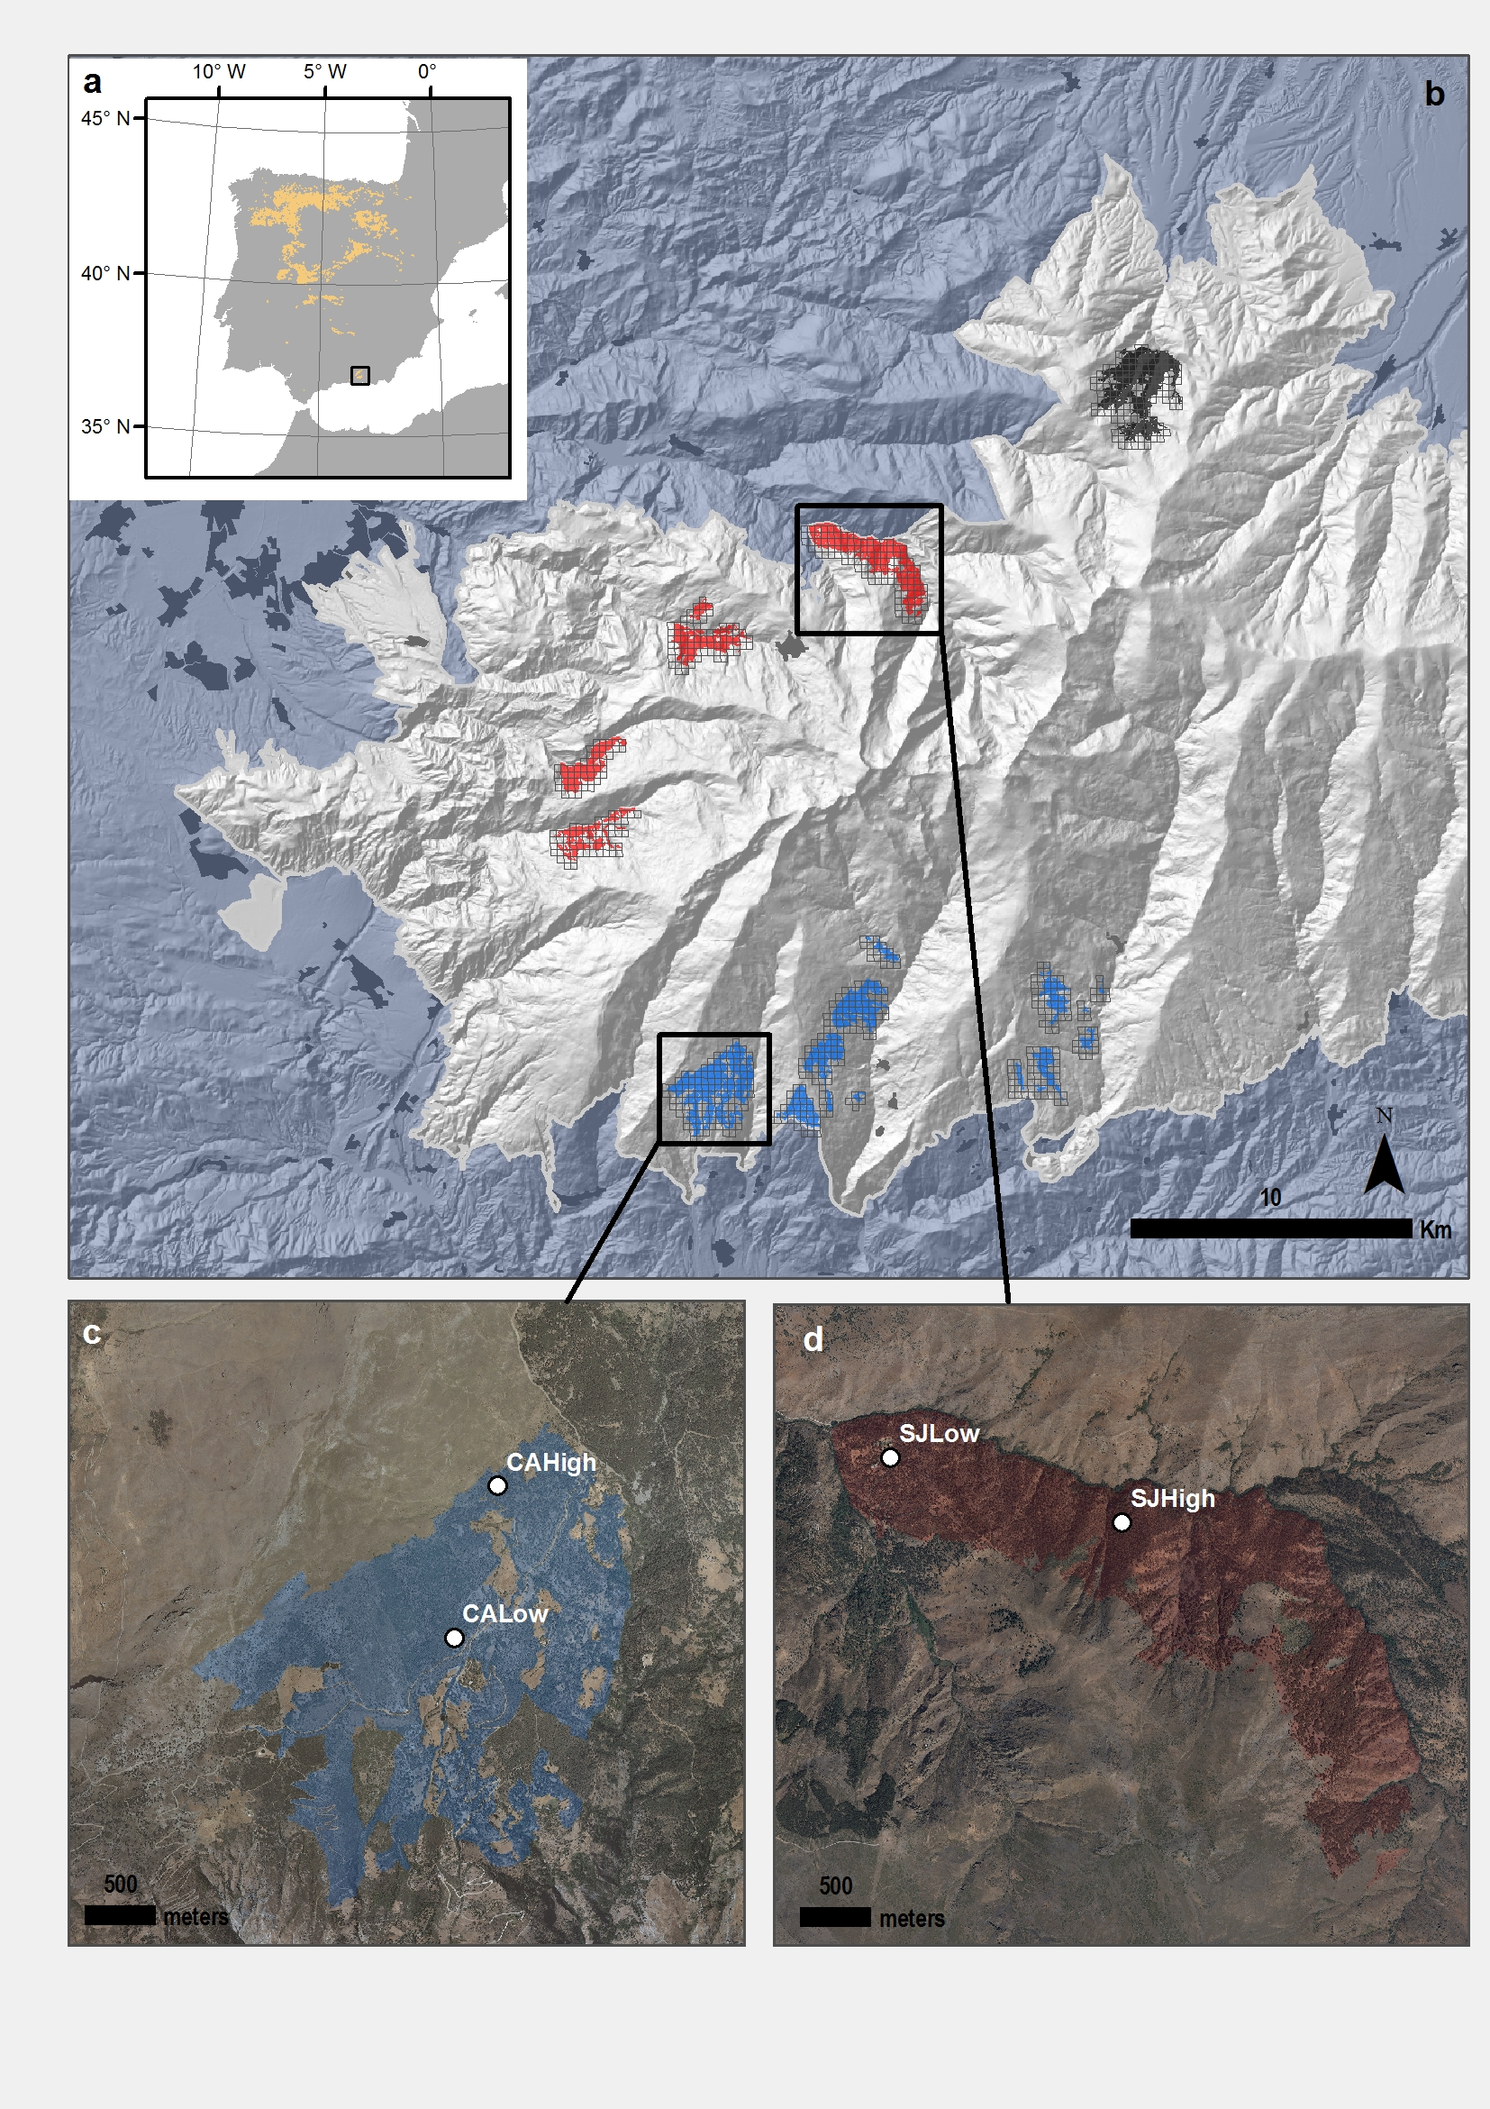

**Figure 1**. Distribution of *Quercus pyrenaica* forests in Iberian Peninsula (a) and in Sierra Nevada mountain range, where three clusters of oak populations have been identified (Pérez-Luque et al. 2015) (showed in different colour) (b). A grid of with the MODIS pixels for each population is shown (see material and methods). Detailed location of the sampling sites: northern (San Juan, SJ) (c) and southern ones (Cáñar: CALow and CAHigh) (d). Colour Orthophotography of 2009 from Regional Ministry of the Environment, Regional Government of Andalusia.

##### 

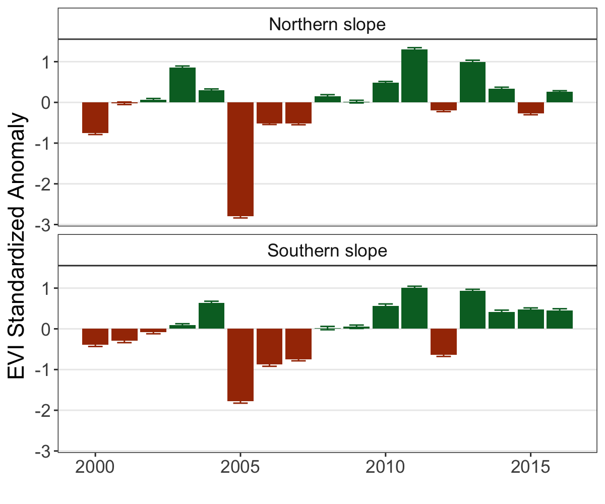

**Figure 2.** EVI standardized anomaly ($EVI sa$) during the period 2000-2016 for northern and southern populations. Error bars show standard error.

##### 

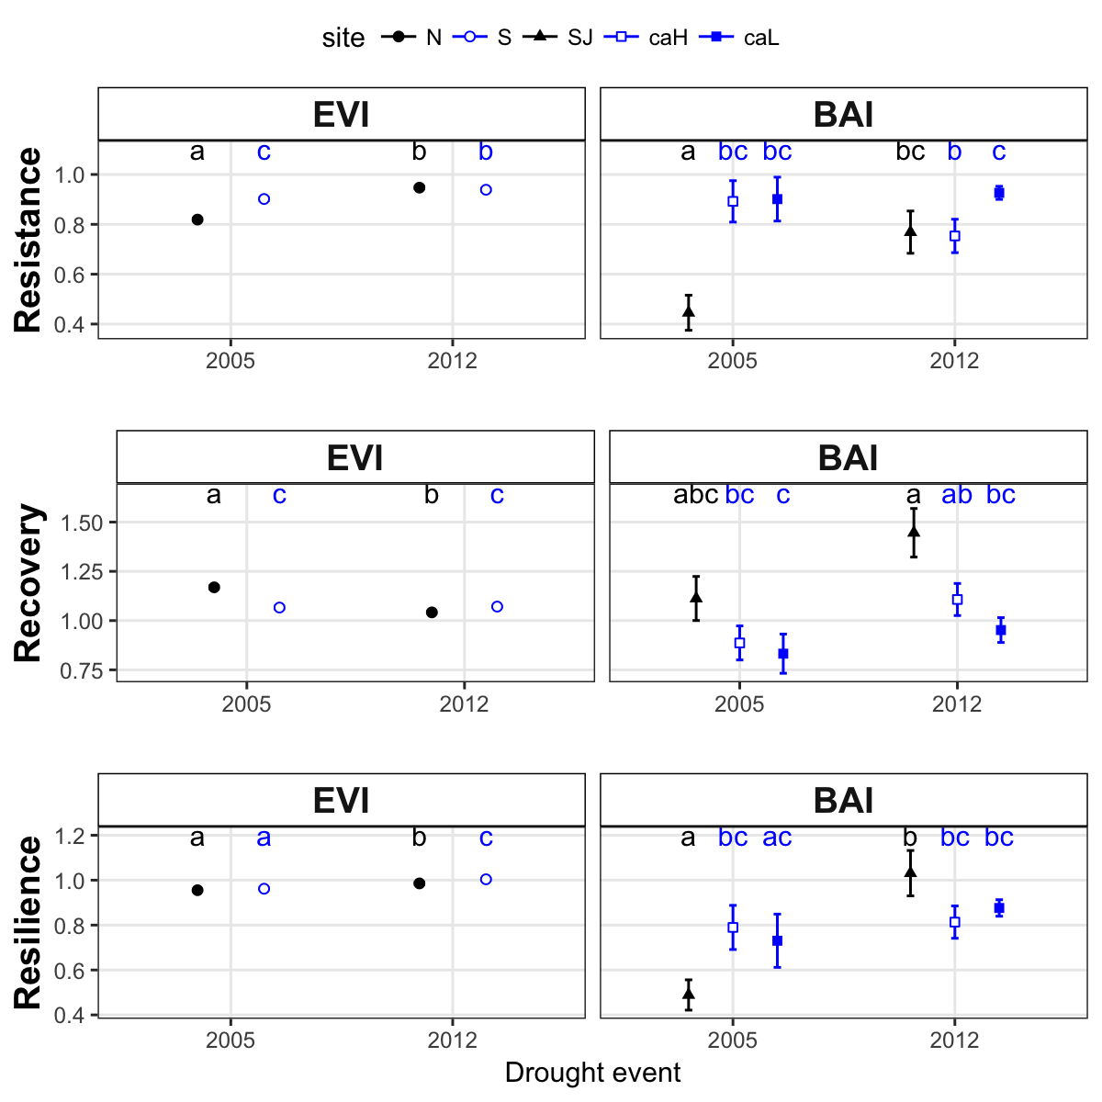

**Figure 3.** Response *Q. pyrenaica* forests to drought in terms of resistance, recovery and resilience of greenness (EVI; left-plots) and tree radial growth (BAI; right-plots) for the years 2005 and 2012. For EVI we compared northern populations (black fill circle) with southern ones (blue empty circle). For BAI we compared northern population (San Juan, SJ; black triangle) with southerns populations: Cáñar-High (Ca-H; blue empty squares) and Cáñar-Low (Ca-L; blue fill sauares). Different letters above error bars indicate significant post hoc differences between groups (see material and methods).

##### 

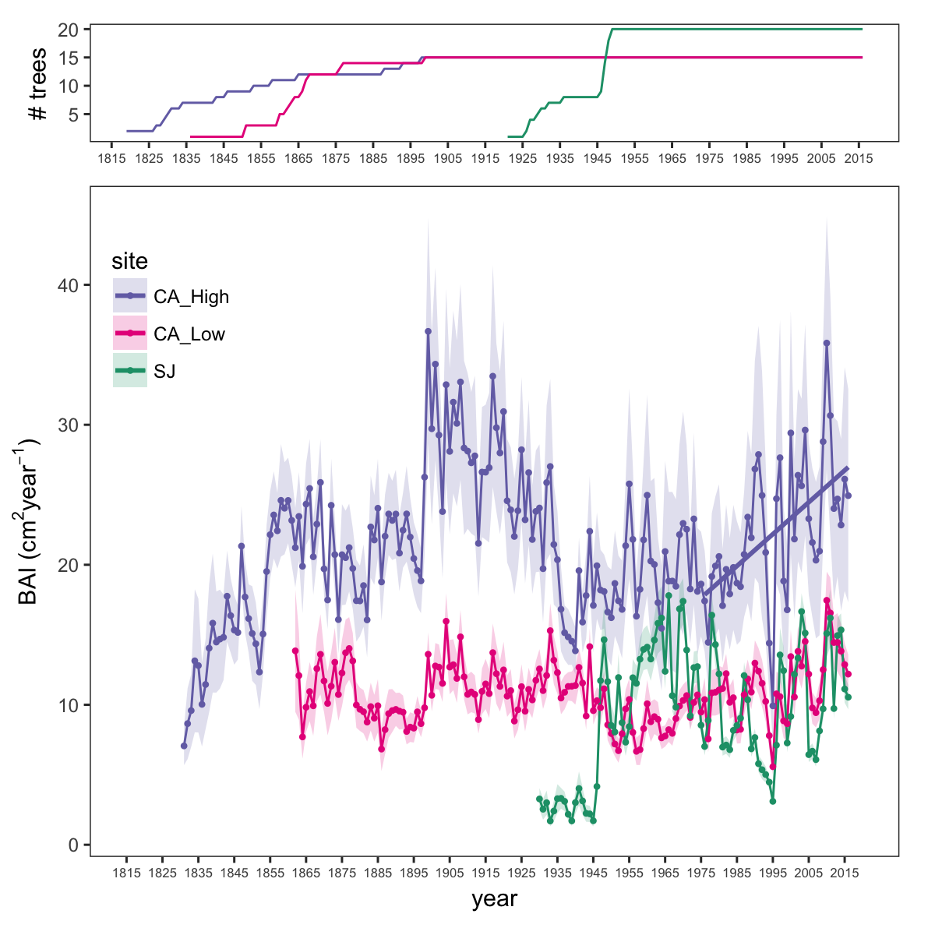

**Figure 4.** Basal Area Increment (BAI) chronologies of *Q. pyrenaica* for northern population (SJ; *green*) and southern ones: low-elevation (CA_Low; *pink*) and high-elevation (CA_High, *purple*) sites. Shading areas coorespond to standard error of the mean. Number of series are displayed in the upper plot. We only show chronologies with # trees > 5.

##### 

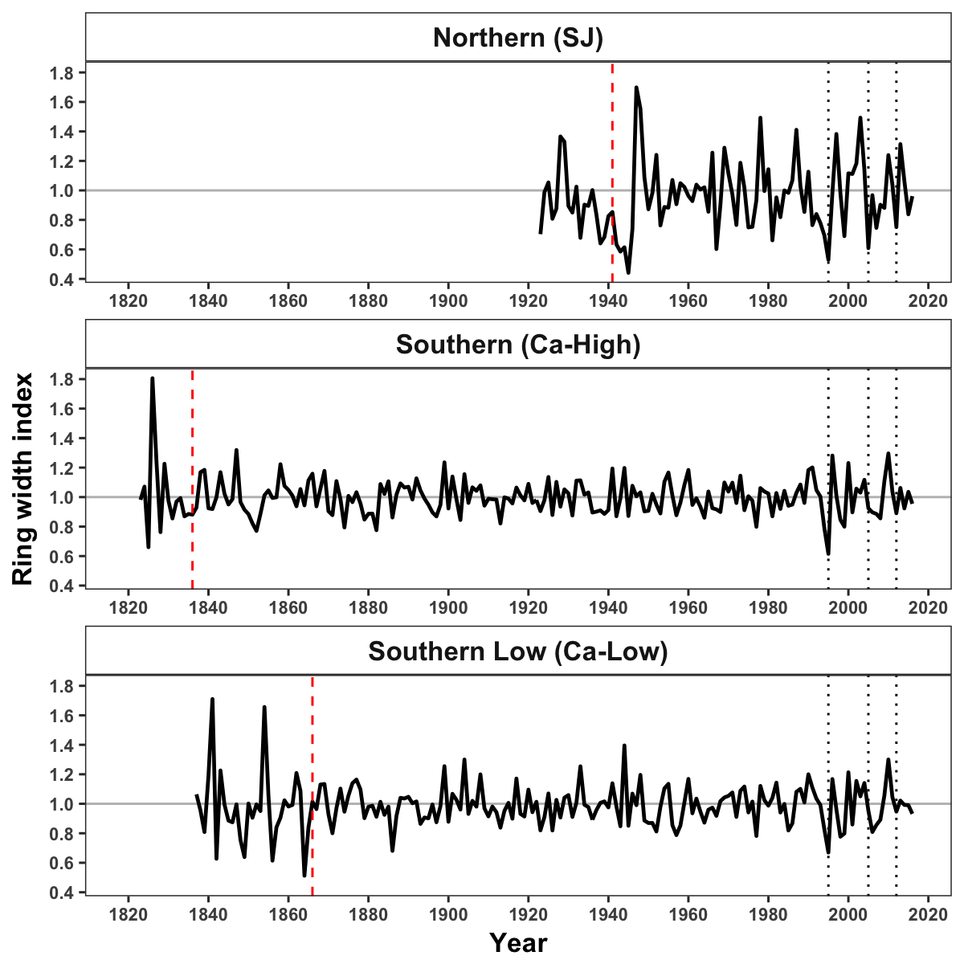

**Figure 5.** Residual Tree-ring chronologies obtained for the *Q. pyrenaica* sites. Dashed red lines indicate the start of the reliable period (EPS > 0.85). Dotted black lines showing the three of most recent severe drought years (1995, 2005 and 2012).

##### 

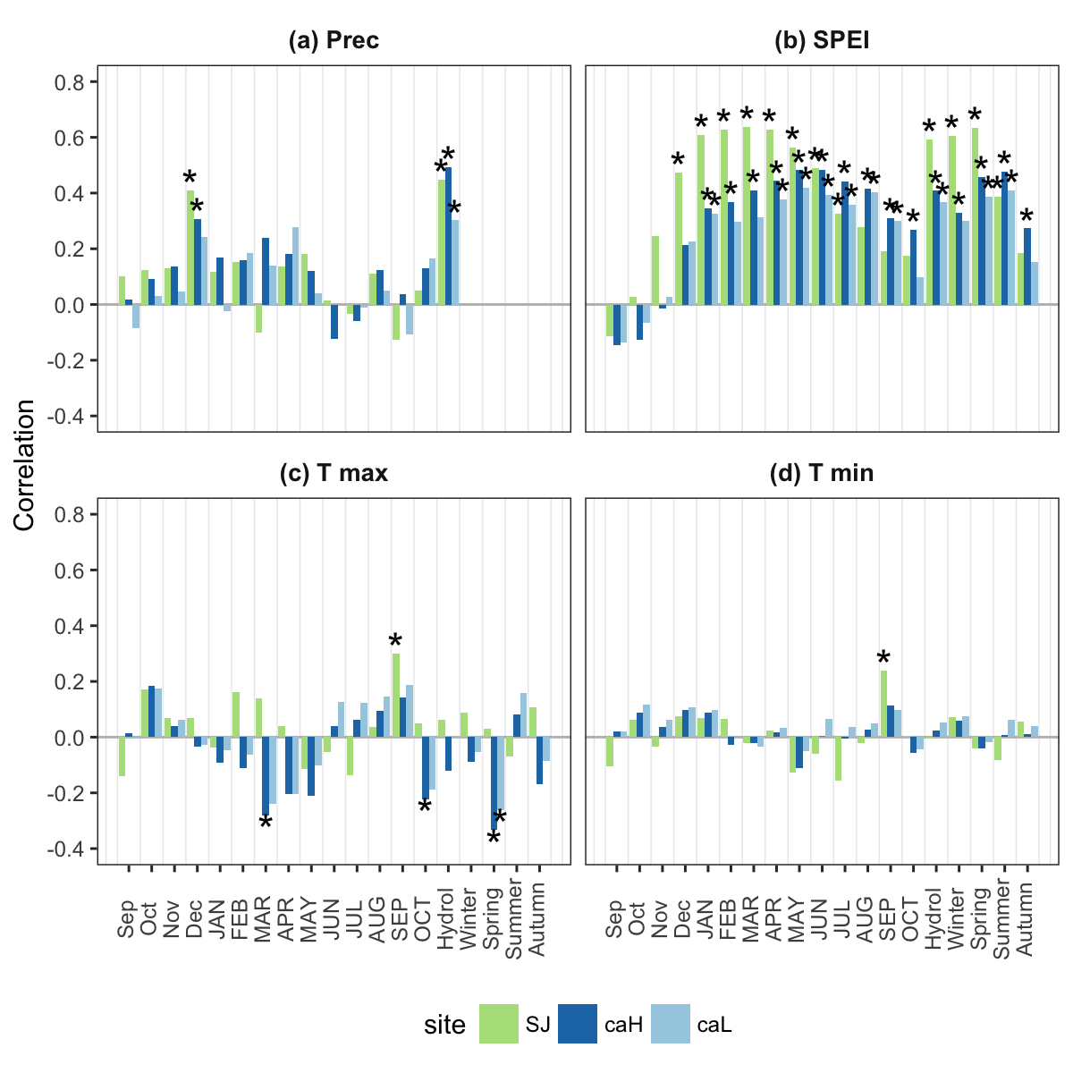

**Figure 6.** Correlation coefficients obtained by relating tree-ring residual chronologies (RWI) of *Q. pyrenaica* and monthly climatic data (precipitation (a), SPEI (b), maximun (c) and minimun (d) temperatures) for northern site (*green* bars), low-elevation southern site (*light blue* bars) and high-elevation shouthern (*dark blue* bars) site. Asteriks indicate significant ($P<0.05$) correlation coefficients.

##### 

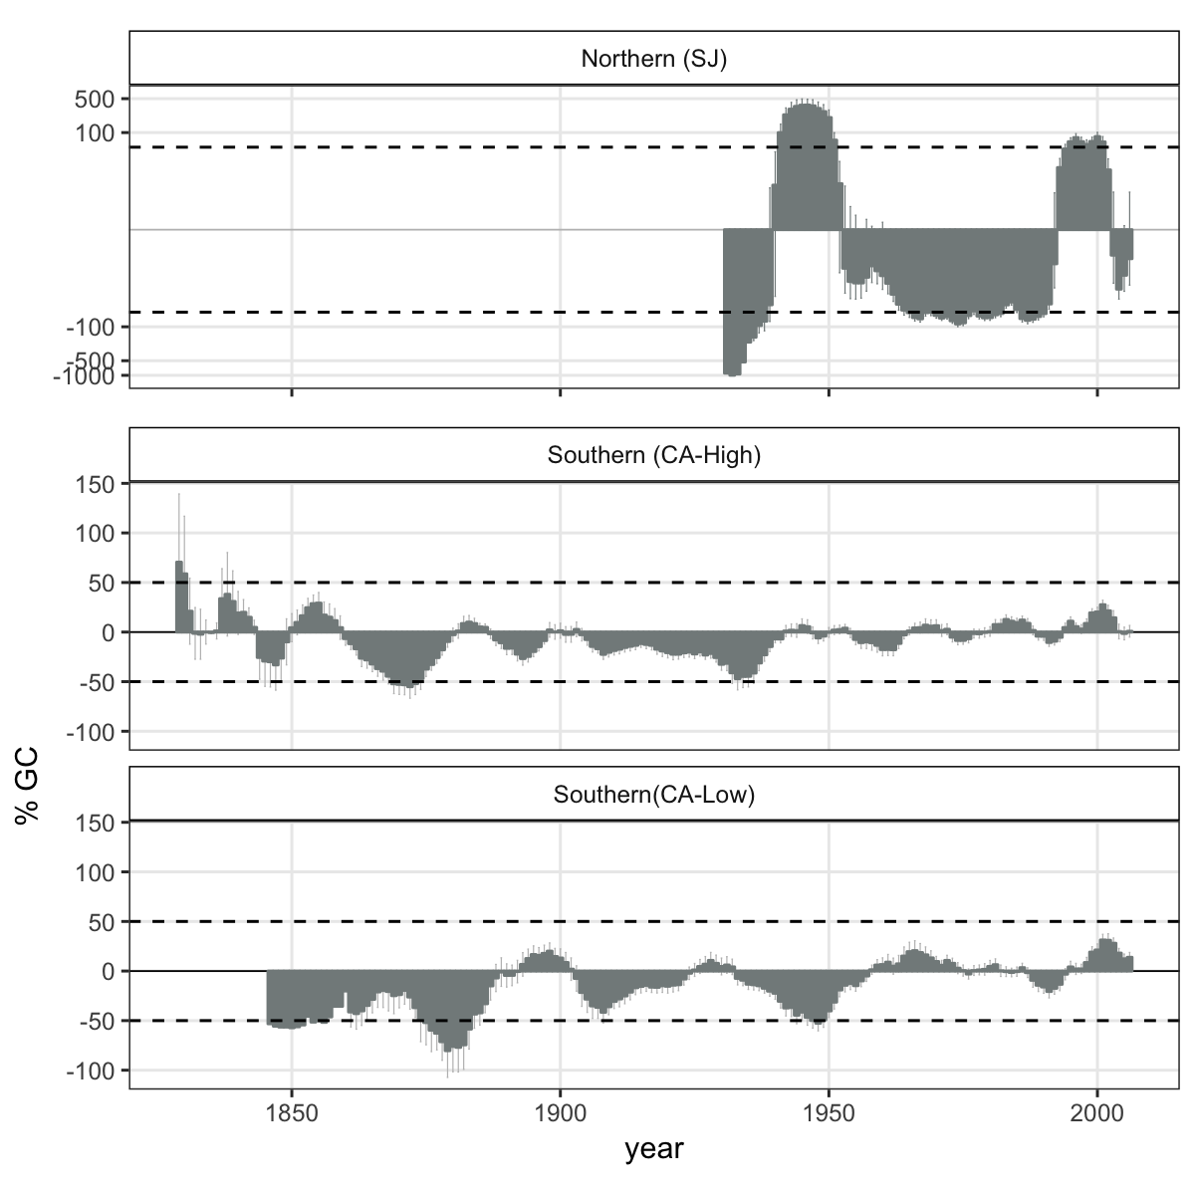

**Figure 7.** Comparison of median growth change ($GC$) following (Nowacki and Abrams 1997) for *Q. pyrenaica* sites. Dashed black lines indicate a threshold of 50 % of GC (see material and methods).

##### 

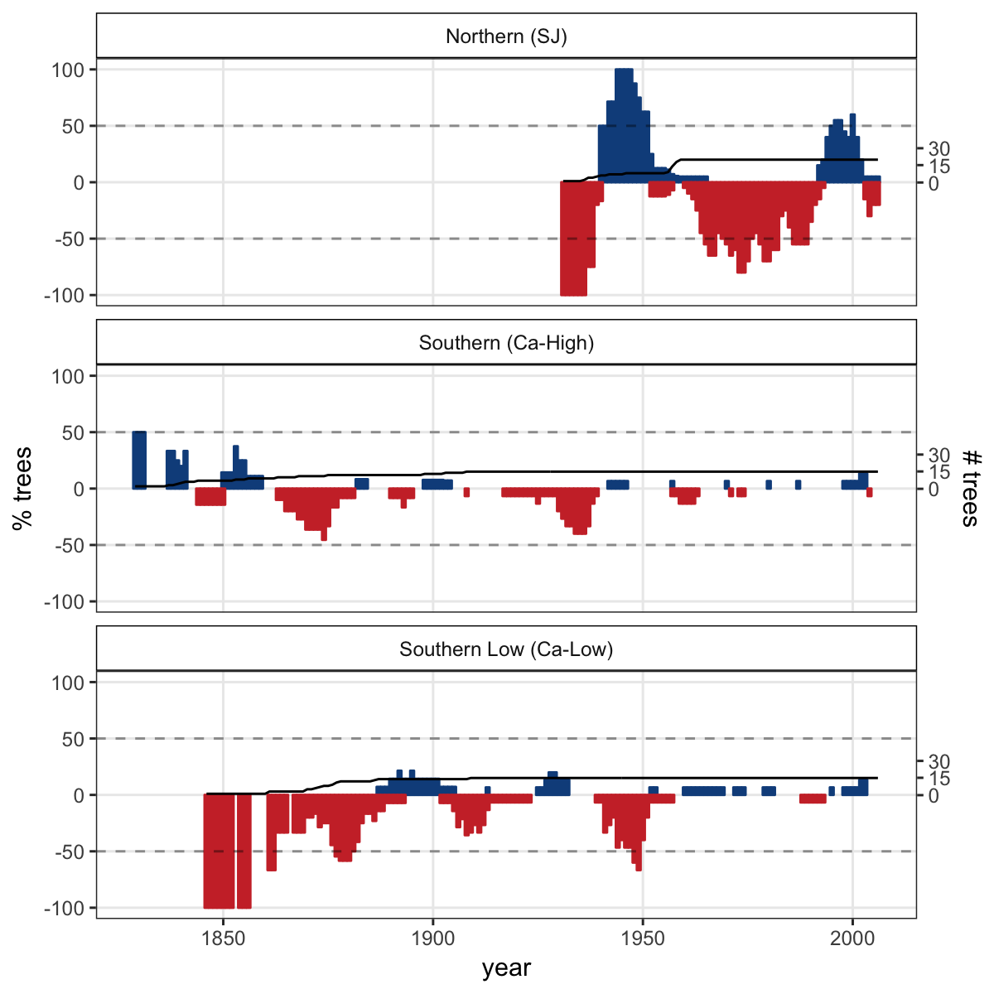

**Figure 8**. Percentage of *Q. pyrenaica* trees affected by GC > 50 % by site. *Black* line shows number of trees (rigth-axis).

# Supplementary

##### 

**Appendix S1** Acumulated monthly precipitation during the hydrological year 2004-2005 (blue line) and 2011-2012 (red line). The boxplot representing the average from 1940-2015 period. Data from meteorological station Granada, Base Aérea (National Spanish Meteorological Services, AEMET).

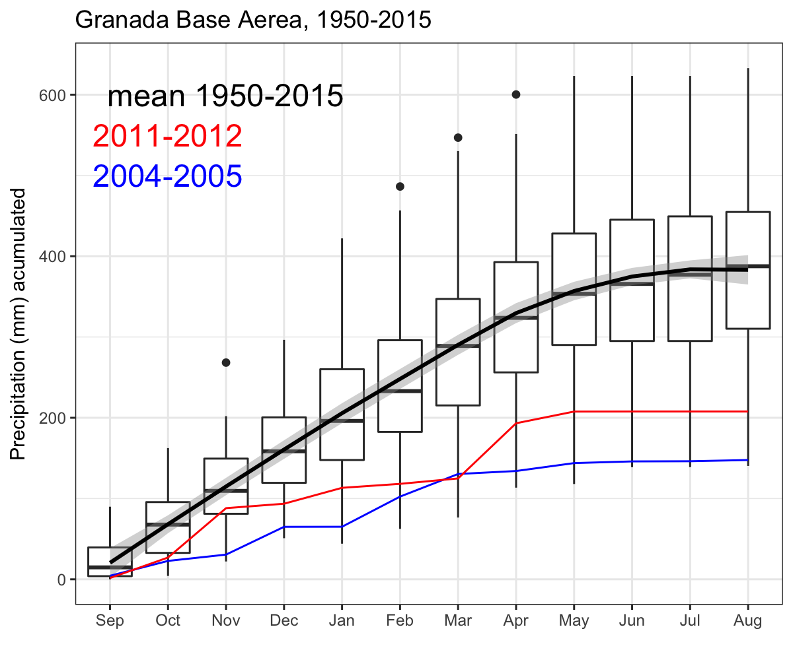

##### 

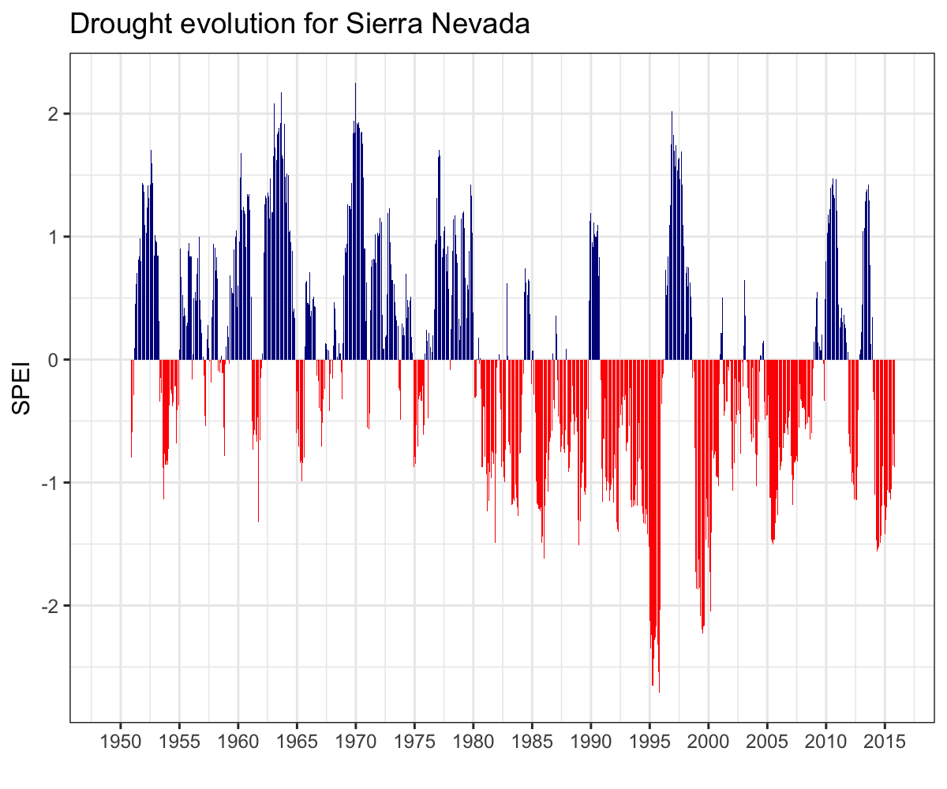

**Appendix S2**. Drought severity in the Sierra Nevada for the 1950-2016 period based on the Standardised Precipitation-Evapotranspiration Index (SPEI). We used data from Global SPEI database. We obtanied the SPEI data for a 12 month scale and for all 0.5º grid cells covering Sierra Nevada.

##### 

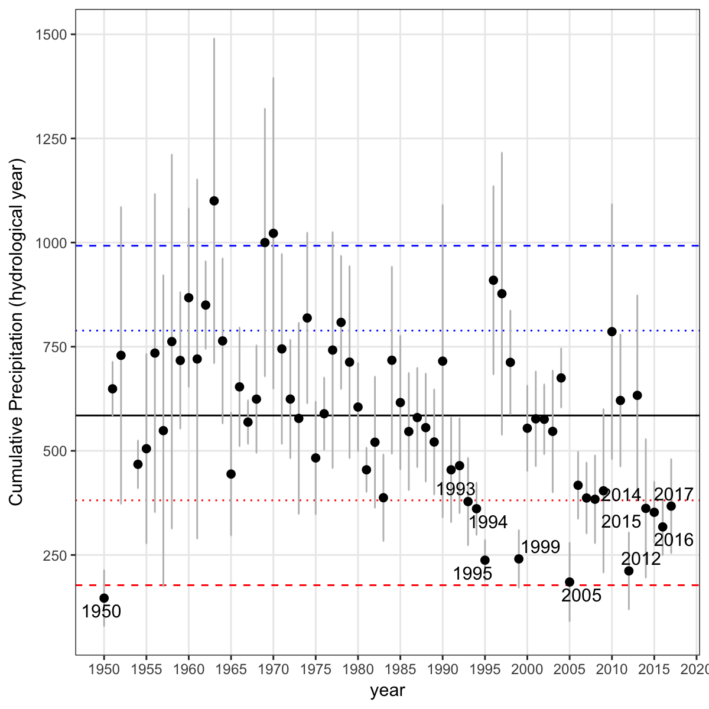

**Appendix S3.** Temporal evolution of cumulative precipitation (hydrological year) during the period 1950-2017 for 28 meteorological stations (from National Spanish Meteorological Services, AEMET) distributed around the Sierra Nevada area. Points represent mean and errorbars standard error. *Black* line indicates mean for all period. *Red* lines represent -1 (*dotted* line) and -2 (*dashed* line) standard deviation. *Blue* lines represent +1 (*dotted* line) and +2 (*dashed* line) standard deviation. We indicate all years with average values below -1SD.

##### 

Table continues below

|  |  |  |  |  |  |
| --- | --- | --- | --- | --- | --- |
| d_duration | d_intensity | d_severity | lowest_spei | month_peak | minyear |
| 11 | -1.581 | 17.39 | -2.024 | 3 | 1913 |
| 11 | -1.957 | 21.52 | -2.585 | 11 | 1995 |
| 9 | -1.823 | 16.41 | -2.427 | 11 | 1945 |
| 9 | -1.764 | 15.88 | -2.056 | 12 | 1998 |
| 8 | -1.482 | 11.86 | -1.654 | 7 | 1983 |
| 6 | -1.728 | 10.37 | -1.906 | 8 | 2012 |
| 5 | -1.905 | 9.527 | -2.3 | 4 | 1925 |
| 5 | -1.493 | 7.463 | -1.537 | 6 | 1985 |
| 5 | -1.385 | 6.926 | -1.444 | 7 | 1991 |
| 5 | -1.522 | 7.611 | -1.571 | 6 | 2005 |
| 4 | -1.363 | 5.453 | -1.441 | 5 | 1927 |
| 4 | -1.714 | 6.855 | -1.833 | 7 | 1931 |

|  |  |
| --- | --- |
| maxyear | cat |
| 1914 | severe |
| 1995 | severe |
| 1946 | severe |
| 1999 | severe |
| 1983 | severe |
| 2012 | severe |
| 1925 | severe |
| 1985 | severe |
| 1991 | severe |
| 2005 | severe |
| 1927 | severe |
| 1931 | severe |

**Appendix S4.** Tabla de drought severas.

##### 

**Appendix S5.** Percentage of pixels showing browning, greenning or no-changes during the 2005 and 2012 droguht events according to EVI standardized anomalies.

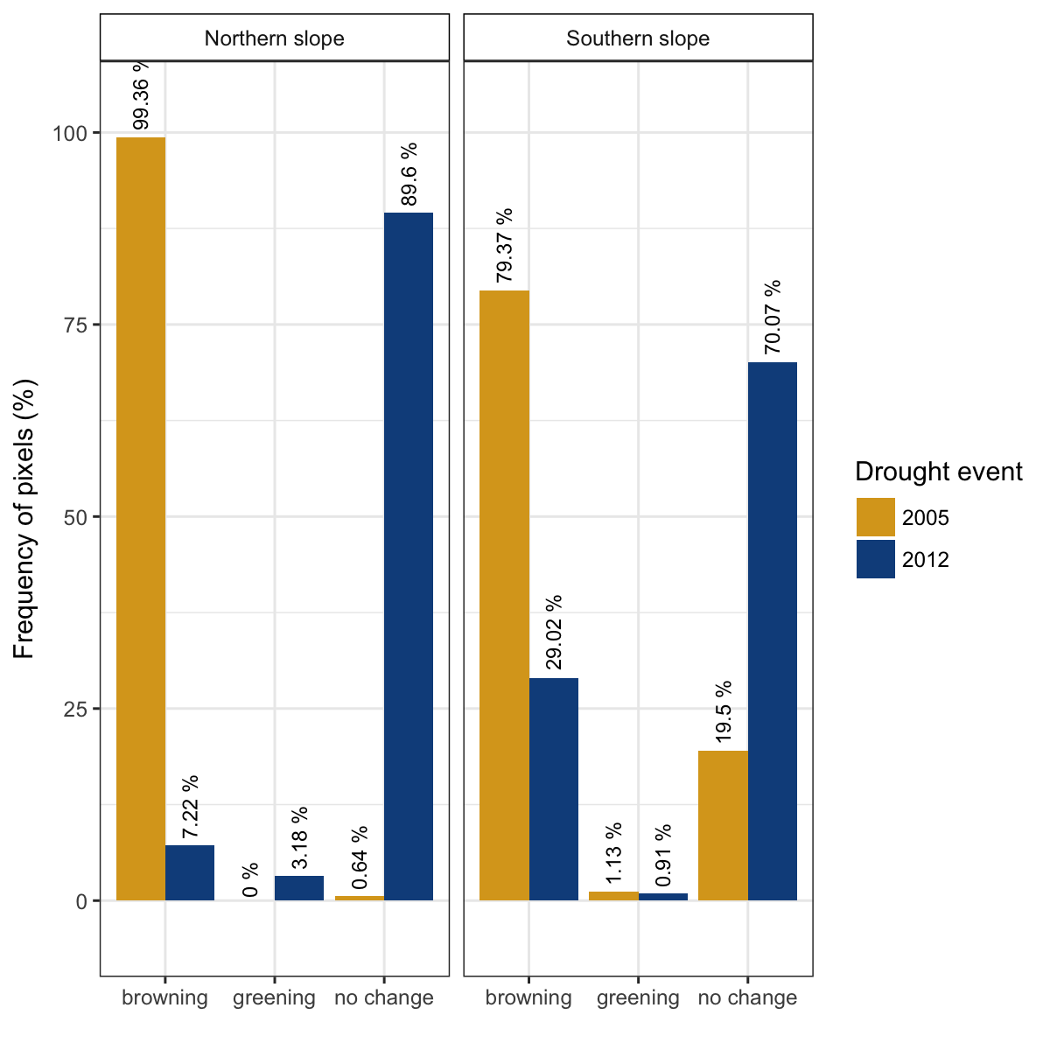

##### 

**Appendix S6.** Reilience vs. droughts

##### 

**Appendix S7.** Correlation between indices of resilience (Rt, resistance; Rc, recovery; Rs, Resilience) using periods of several lengths (2, 3 and 4 years after a drought). Top plots (a, b and c) showing the resilience indices of greenness (EVI) to drought; and bottom plots (d, e, f) the resilience indices of tree-growth (BAI) to drought. ws2, ws3 and ws4 indicate periods of 2, 3 and 4 years after a drought.

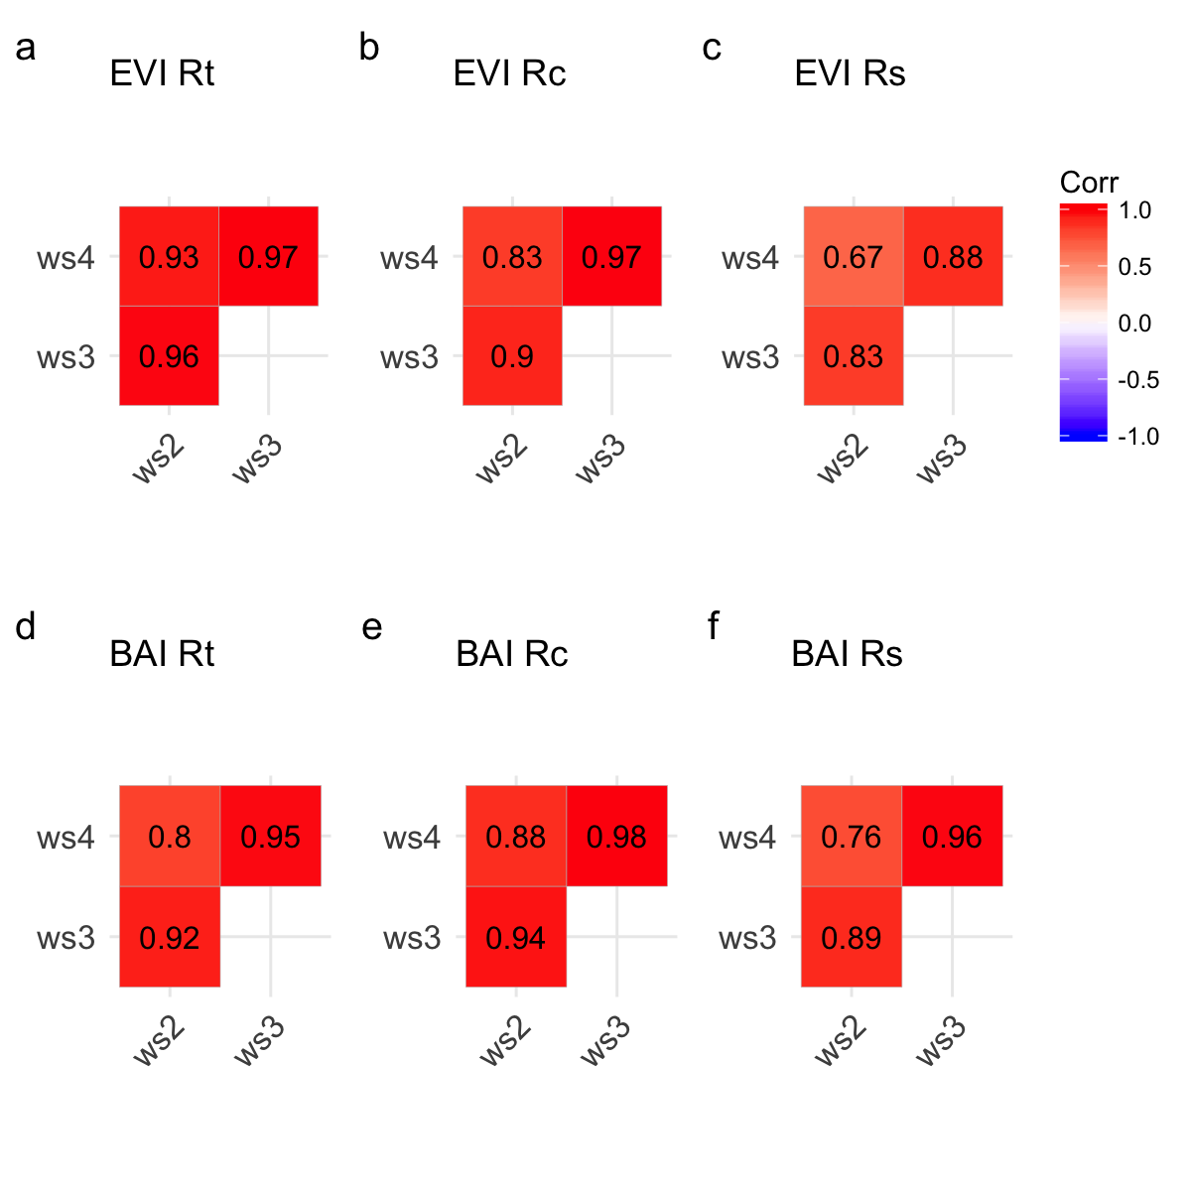

##### 

**Appendix S8.** Tabla S1

##### 

**Appendix S9.** Tabla S2

Nowacki, G. J., and M. D. Abrams. 1997. Radial-growth averaging criteria for reconstructing disturbance histories from presettlement-origing oaks. Ecological Monographs 67:225–249.

Pérez-Luque, A. J., R. Zamora, F. J. Bonet, and R. Pérez-Pérez. 2015. Dataset of migrame project (global change, altitudinal range shift and colonization of degraded habitats in mediterranean mountains). PhytoKeys 56:61–81.